**Lampiran 8**

**Hasil Uji Asumsi: Normalitas**

**UJI NORMALITAS KEPEMILIKAN PSIKOLOGIS**

|  |  |  |  |  |  |  |
| --- | --- | --- | --- | --- | --- | --- |
| **Tests of Normality** | | | | | | |
|  | Kolmogorov-Smirnova | | | Shapiro-Wilk | | |
| Statistic | df | Sig. | Statistic | df | Sig. |
| KEPEMILIKAN PSIKOLOGIS | .058 | 200 | .096 | .986 | 200 | .040 |
| KONFORMITAS | .124 | 200 | .000 | .965 | 200 | .000 |
| PEMUJAAN IDOLA | .088 | 200 | .001 | .984 | 200 | .022 |
| IDENTITAS DIRI | .068 | 200 | .027 | .981 | 200 | .009 |
| a. Lilliefors Significance Correction | | | | | | |

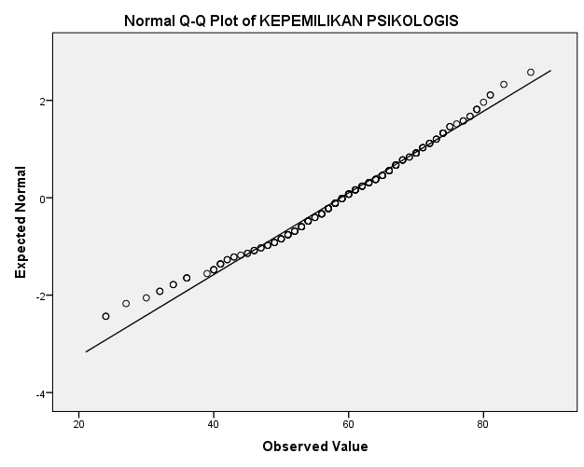

**UJI NORMALITAS KONFORMITAS**

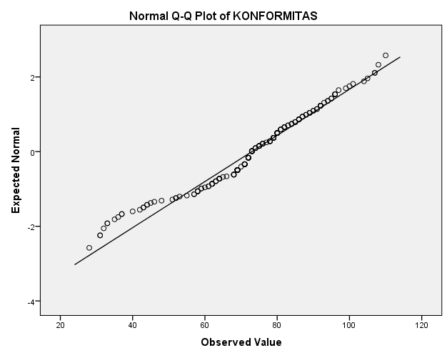

**UJI NORMALITAS PEMUJAAN IDOLA**

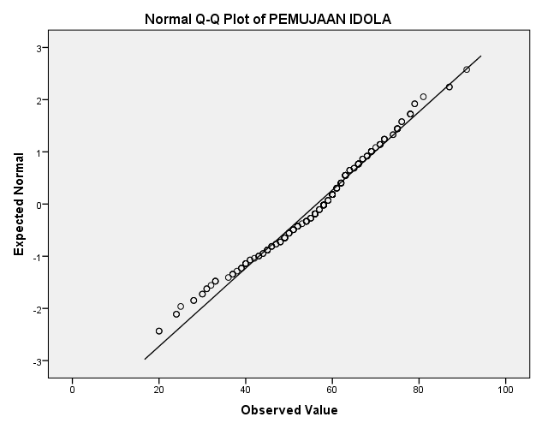

**UJI NORMALITAS IDENTITAS DIRI**

